Maps Skills Quiz Review

Name_____________________________ Date____________

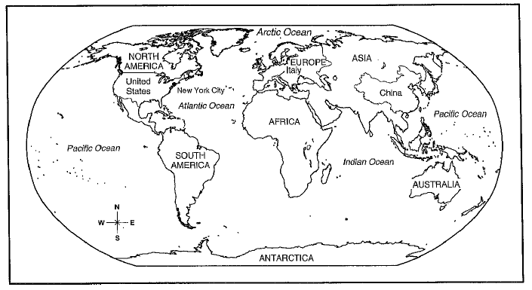

- Which continent is the farthest south? ______________
- To travel directly from South America to Europe, which direction would you go? (Northwest, Northeast)? ________________
- Which ocean touches both Asia and South America? ________________
- Which ocean is farthest north? ____________________
- What hemispheres is South America located in? ____________________
- What hemispheres is North America located in? ____________________
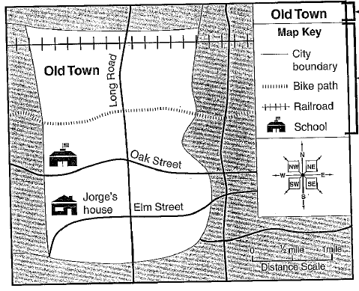
- What is the title of the map? ___________________
- What does this symbol mean? __________________
- Which direction would you go from the school to Jorge’s house? ________________
- Name the 5 Oceans.
_____________________ ____________________
_____________________ ____________________
_____________________

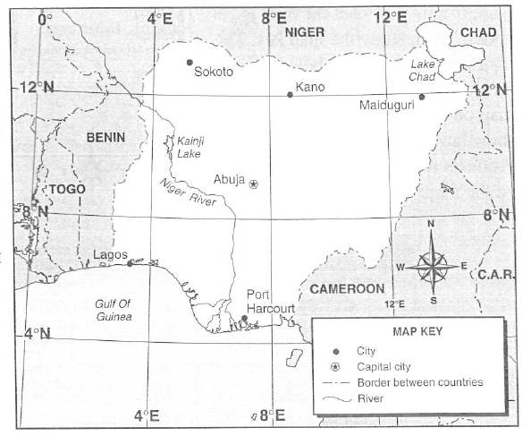
- Which two cities are located near 7° E? __________________________
- Which city has a latitude and longitude of about 6°N, 3°E? ____________________
- What are the approximate coordinates of Abuja? ___________________
- Name the 7 continents.
______________________ ___________________
______________________ ___________________
_____________________ ___________________
_____________________

