2016-2017
Social Studies Research Project
Requirements

Theme: Taking a Stand
Due: January 31, 2017

One of the requirements of 6th Grade Social Studies is to complete a major research project. To do this you must include the following:
- A minimum of 10 sources
  - 2 print sources (books, encyclopedia, etc.)
  - 2 web sources
  - 1 database (EBSCO)
  - 5 photographs
  - 2 of your 10 sources must be primary sources
- You must have a bibliography
  - The bibliography must follow MLA guidelines and be annotated. You will use NoodleTools to create this bibliography.
  - Your bibliography must be a separate document. Do NOT attach it to your project board!
- You must have a historical thesis statement.
  - a short declaration of your argument which is 3-4 sentences.
  - your thesis statement must be included on your project board.
- You must have some main points:
  - Make certain that everything you include relates clearly to your thesis and helps you make your case.
  - Do not just restate facts in your project. Your project should tell a story of its importance in history and its relation to the theme. Include the following:
    - Evidence
    - Analysis - Detailed Study
    - Why the topic is important to history
    - Clearly connects topic to theme
- Your research will be presented as an exhibit, a website, or a documentary.
  - You must place your information on an exhibit tri-fold board or meet the guidelines provided for alternate projects.
  - It is strongly recommended that you type and print your information, but it is not required.
  - All pictures should have captions and support your thesis.

What is a Source?
A source is someone or something, like a book or article, that provides information on a topic.

We are looking for two types of sources.
Primary Sources
A primary source is a piece of information about a historical event or period in which the creator of the source was an actual participant in or a contemporary of a historical moment. The purpose of primary sources is to capture the words, the thoughts and the intentions of the past. Primary sources help you to interpret what happened and why it happened.
Examples of primary sources include: documents, artifacts, historic sites, songs, or other written and tangible items created during the historical period you are studying.

Secondary Sources
A secondary source is a source that was not created first-hand by someone who participated in the historical era. Secondary sources are usually created by historians, but based on the historian’s reading of primary sources. Secondary sources are usually written decades, if not centuries, after the event occurred by people who did not live through or participate in the event or issue. The purpose of a secondary source is to help build the story of your research from multiple perspectives and to give your research historical context.
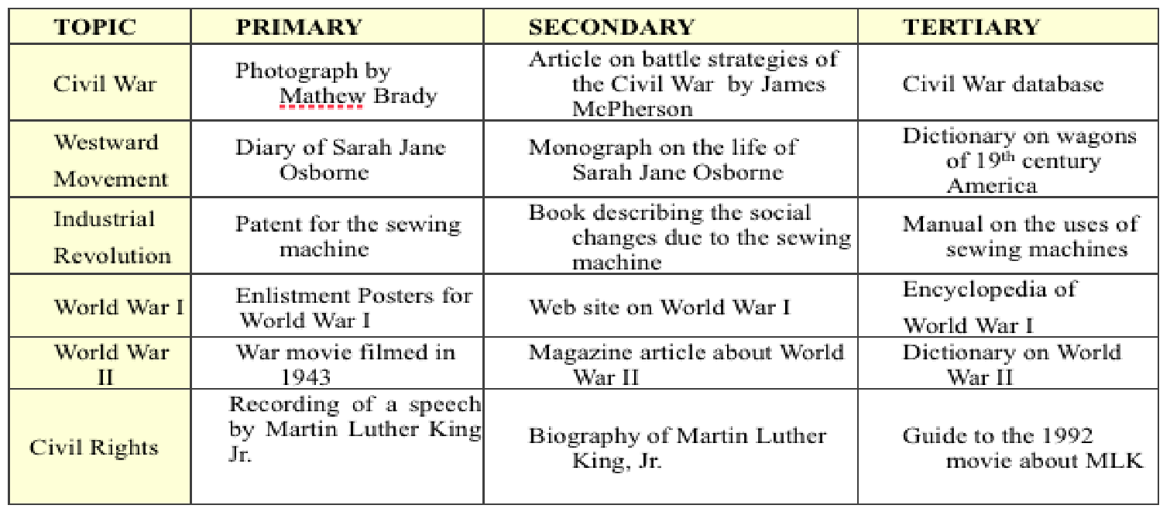

Note Taking
Quotations must be identical to the original source. They must match the document word for word and must be credited to the original author.
- You must copy the source material word for word and put quotation marks around it.
- Select quotations from authorities on your subject.
- Work quotations smoothly into your project.
- Cite your source.

Summary/Paraphrasing involves putting the main idea(s) into your own words. Take a statement and restate it in your own words.
- Identify the main points.
- Condense the main points without losing the essence of the material.
- Summarize a source when readers need to know the essential points, but not all the details.
- Paraphrase a source when a good portion of information is needed, but you want to limit your quotes and maintain your own voice in the project.
- Reproduce the source’s order of ideas.
- Use your own words and phrases
- Cite your source.

Developing a Thesis Statement
NHD projects should do more than just tell a story. Every exhibit, performance, documentary, paper and website should make a point about its topic. To do this, you must develop your own argument of the historical impact of the person, event, pattern or idea you are studying. The point you make is called a thesis statement. A thesis statement is not the same as a topic. Your thesis statement explains what you believe to be the impact and significance of your topic in history. Example:
Topic: Battle of Gettysburg
Thesis Statement: The battle of Gettysburg was a major turning point of the Civil War. It turned the tide of the war from the South to the North, pushing back Lee’s army that would never fight again on Northern soil and bringing confidence to the Union army.

A thesis statement should:
- Address a narrow topic
- Explain the significance of your topic
- Make a claim or take a stand that you will argue in the rest of your project
- Be supported by your sources
- Connect the topic to the NHD theme
- Be clear and concisely written and easily found by the audience
- Answer the question: Why is this topic significant?

Research Checklist

Have you….

Searched the school library for books (Did you ask Ms. Hennesy for help?)

Searched under your subject’s name(s)

Searched the name of key associates of that person or people associated with the event

Searched the name of key events with which your person was associated

Searched the school’s electronic databases for articles and primary sources (EBSCO)

Searched under your subject’s name(s)

Searched the name of key associates of that person or people associated with the event

Searched the name of key events with which your person was associated

In the public library:

Searched the shelves (history and biography sections)

Searched the name of key associates of that person

Searched the name of key events with which your person was associated

Searched the National Geographic Index

Searched the reference book shelves

Searched the name of key events with which your person was associated

On the Internet:

Search the course website for research resources in your time period.

Google keywords (you never know what you might find)

Google keywords (using site:edu)

Google for primary sources (“Eleanor Roosevelt primary source”)

Repeat process using other keywords

Searched the OAH Magazine of History site

http://www.oah.org/pubs/magazine/

Search the American Heritage website

http://www.americanheritage.com/

Search the History Net website

http://www.historynet.com/
Exhibit Verification Checklist
WRITTEN MATERIALS
􀂗 Requirement:
- I have supplied a title page. The title page includes:
  - the title of the exhibit, the names of the creator(s), and count of student-composed words on board
  - No other information (school, state, teacher, course) is contained on this page.
- There is an annotated bibliography that contains:
  - a complete list of all sources used to create this entry separated into primary and secondary sources
  - annotations for each entry
EXHIBIT RULES
􀂗 Requirement:
- My exhibit meets the size requirements:
  - The exhibit is no larger than 40 inches wide, 30 inches deep, and 6 feet high
OR
  - If the exhibit is circular or rotating, it is no more than 30 inches in diameter
- My exhibit contains 500 or fewer student-composed words (excluding brief citations that credit sources.)
- I know that any media devices must not run for more than three minutes. I/we know that any student narration in the media will count towards the 500-word limit.
- I have credited all sources on the exhibit itself and cited all sources in the annotated bibliography.

Website Verification Checklist
WRITTEN MATERIALS
􀂗 Requirement:
- Website has no more than 1,200 student-composed words, excluding:
  - brief citations that credit sources
  - recurring menus, titles, and navigation instructions
  - word count notifications
  - primary sources
  - annotated bibliography
- There is an annotated bibliography within the website that contains:
  - a complete list of all sources used to create this entry separated into primary and secondary sources
  - annotations for each entry
WEBSITE RULES
􀂗 Requirement:
- One page must be a home page including:
  - title
  - name(s) of participants
  - number of student-composed words in the website
  - number of words in the process paper
  - menu to access the other parts of the website
- All pages can connect by clicking links. I have checked all of my links to make sure that they work.
- I have no more than four (4) minutes of multimedia (music and video) in the entire website.
- I have all materials (pictures, primary sources, multimedia) included in the website, not linked to another website.
- I have credited all materials (pictures, primary sources, multimedia) where they are placed in the website and in the annotated bibliography included in the website.
- I know the website can be viewed on multiple browsers (Firefox, Google Chrome, etc.)

