Canada Quiz Review

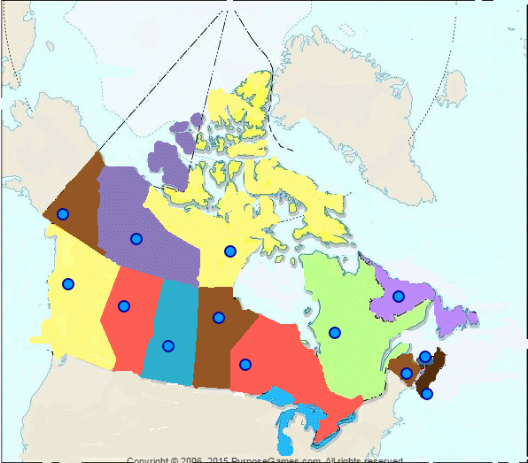
1
13
12
11
10010
9
8
5
7
6
4
3
2

Provinces and Territories:
Write the name of the province or territory on the correct line.

Alberta
British Columbia
Manitoba
New Brunswick
Newfoundland and Labrador
Northwest Territories
Nova Scotia
Nunavut
Ontario
Prince Edward Island
Quebec
Saskatchewan
Yukon Territory

- _________________________ 8. _________________________
- _________________________ 9. _________________________
- _________________________ 10. _________________________
- _________________________ 11. _________________________
- _________________________ 12. _________________________
- _________________________ 13. _________________________
- _________________________

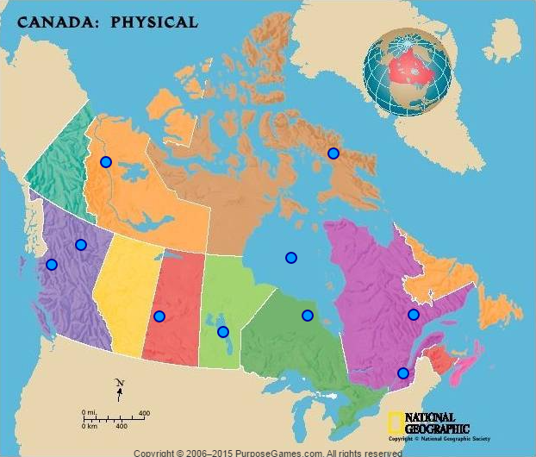
23
22
21
19
20
18
17
16
15
14

Physical Features
Write the name of the physical feature on the correct line.

Baffin Island
Canadian Shield
Coast Mountains
Hudson Bay
Interior Plains
Lake Winnipeg
Laurentian Highlands
Makenzie River
Rocky Mountains
St. Lawrence River

14. _________________________ 19. _________________________
15. _________________________ 20. _________________________
16. _________________________ 21. _________________________
17. _________________________ 22. _________________________
18. _________________________ 23. _________________________
24. Who built the St. Lawrence Seaway?

25. When was the St. Lawrence Seaway completed?

26. Why was the St. Lawrence Seaway built?

27. Who were the first Europeans to reach Canada?

28. When did Samuel de Champlain establish Quebec?

29. Who is the official head of state of Canada?

30. Who is the leader of the government of Canada?

31. Where is Canada’s national capital?

32. Where do most of the Inuit live?

33. What are the two official languages of Canada?

34. What are the major industries of the Atlantic Region?

35. What region has the largest population and industry?

36. Why are the Prairie Provinces called Canada’s Breadbasket?

